RM 168-96 Reference plate instruction manual.

PLEASE READ CAREFULLY.

- Ensure that no lint or any other material (liquid, etc) is in the light well.
- Do not use any cleaning agent to clean the unit. We recommend using a very soft brush to clean the well windows, avoid scratching the windows.
- Do not put any pressure on the light well window or on the back side of the unit.
- Do not subject the unit to shock, excessive heat or direct sunlight, it is best to keep the unit in its storage case.
- Always turn the unit OFF after each use, DO NOT leave the plate in the machine.
- Check battery status before each use, when the battery is weak, replace the battery (see service instruction).
- No user serviceable parts inside, do not attempt to open the unit, as this will destroy the unit, Do not turn or adjust any screws other than the two screws marked “BATTERY ACCESS” on the back panel
- Keep the unit, (turned OFF), in it’s storage case when not in use.
- To operate, Power Switch (1) have to be on I, and Activation Switch (4) has to be pressed, in a machine where switch 4 is not pressed, put a piece of tape to hold switch 4 down, and TURN OFF switch 1 as soon as the test is done, to preserve battery life.

Instruction for first time user:

Establish a baseline data for your particular luminometer:

- Turn On the Power Switch (to I) on the bottom side of the unit using the supplied tool.
- Test the battery using the supplied tool, by pressing the TEST button, while pressing the activation switch using the supplied tool. If the TEST light is ON, the battery is OK. If the TEST light is not ON, the battery is weak, see service instruction.
- Verify the performance of the luminometer by other means (i.e. serial dilution of ATP, etc.)
- Place the unit in luminometer, and read the unit several times, calculate the average reading result, and write it down and keep it as a record. These numbers will be the baseline for this unit.

Service:
When the battery is weak, order replacement battery from Harta Instruments, at the address shown on the back cover of the unit, by phone, fax or email. Our email address is: harta@erols.com. Remove the two screws marked “BATTERY ACCESS” on the left side of the back covers.
Gently remove the old battery from the connectors, and replace with the new battery, making sure that the connectors are properly inserted all the way. Reinstall the cover with the two screws.
CAUTION: DO NOT REMOVE OR TURN ANY OTHER SCREWS. Removing or turning any other screws will void the warranty and render the unit inoperable and irrepairable.

USE BATTERY FROM HARTA INSTRUMENTS ONLY, these batteries are custom manufactured for use in these plates. Use of other batteries may damage the unit and will void warranty.

Warranty:
Harta warrants this product, except the battery, to be free from manufacturing defects in materials and workmanship for one year from the date of purchase. This warranty does not cover damage resulting from abuse, misuse, neglect, abnormal use, mishandling, spillage, removal or turning of screws other than the BATTERY ACCESS screws.

BRK-168 BATTERY REPLACEMENT KIT
- The Battery Replacement Kit should contain:
    - 1 Battery Pak
    - 1 Battery test tool
    - 4 Battery compartment replacement screws
- Switch OFF the unit.
- Remove the four screws marked “BATTERY ACCESS” on the small battery
compartment lid at the back of the unit, using the screwdriver supplied with the plate
- Remove the battery compartment lid.
- Carefully remove the battery-pack.
- Remove the connectors connecting the battery-pack to the unit.
- Remove the new battery-pack from it’s plastic bag.
- Connect the RED wire of the battery-pack to the RED wire from the unit.
- Connect the BLACK wire of the battery-pack to the BLACK wire from the unit.
- Ensure that the wires will not obstruct or get pinched by the lid.
- Replace the battery compartment lid.
- Fasten the lid, do not over-torque the screws.

1: Power Switch 1 = ‘ON’, 0 = ‘OFF’
2: Battery test switch
3: Battery test indicator
4: Activation switch
5: Battery compartment access screws

1
2
3
4

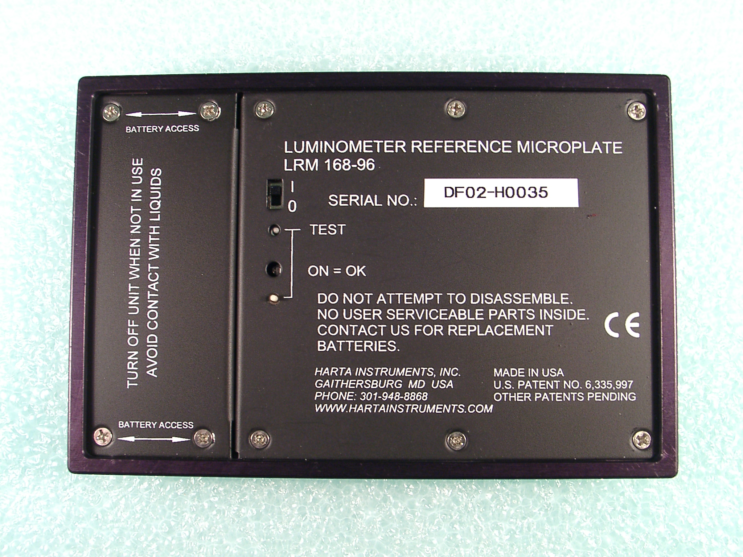

5

