SETUP OF MICROLUMI XSi WITH INJECTOR(S)

CAUTION:
- TURN OFF THE MICROLUMI-XS BEFORE INSTALLING OR REMOVING ANY CABLES (POWER CABLE, INJECTOR CABLES).
- ALWAYS USE THE ORIGINAL INJECTOR CABLES, USE OF OTHER CABLES WILL DAMAGE THE UNITS AND WILL VOID WARRANTY.
- ALWAYS EVACUATE THE INJECTORS IF THEY ARE NOT GOING TO BE USED FOR PROLONGED PERIOD.
- FOR REPLACEMENT CABLES OR ANY OTHER PARTS, CONTACT HARTA INSTRUMENTS.

CONNECTING THE INJECTORS TO THE LUMINOMETER:
- Turn OFF the luminometer.
- Black tubing with two fittings :
  - Connect Blue ¼-28 fitting to “OUT” port of the valve (see fig 1, “A”)
  - Connect Male Luer fitting to the back of the MicroLumi XS.
- Clear tubing with one fitting:
  - Connect the ¼-28 fitting to “IN” port of the valve (see fig 1, “B”)
  - Dip the other end into the fluid to be injected.
- Attach cables from the back of machine to it’s corresponding injectors.

REPLACING THE SYRINGE:
Use only Becton Dickinson Part# 309628 1 ml syringe, use of any other type of syringe may not be accurate and may cause damage to the machine. Additional syringes available from Harta Instruments, Inc.
- From Lumiterm, evacuate the injector(s)
- At the end of evacuate cycle, the injector arm will be down.
- Release the plunger holder lever
- Unscrew the syringe
- Screw-in a new syringe
- Make sure the syringe tube wings are paralel to the front panel, to prevent injector arm to interfere with the syringe tube (see fig. 2, “A”)
- Tighten the plunger holder lever (see fig. 2, “B”)

REPLACING TUBING:
- From Lumiterm, evacuate the injector(s)
- Turn OFF the luminometer
- Remove the fitting from the valve body
- Remove the Luer from the back of MicroLumi XS
- Replace tubing
- Additional Fittings are available from Harta Instruments Inc

PRIMING THE INJECTOR:
CAUTION:
FOR RELIABLE OPERATION, IT IS IMPORTANT TO ENSURE THERE’S NO AIR COLUMN IN THE PIPELINE. FOLLOW THE FOLLOWING PROCESS:
- Place an empty microplate in the MicroLumi XS tray (use microplate with microwell volume > 200 uL), close the tray
- Remove luer(s) from the back of luminometer, and loop it back to it’s supply container
- From “Options”, select columns A, B and C
- Select “Flash”
- for each active injectors:
  - Set “Volume” to 100 uL
  - “Delay” = 0
  - “Read” = 1
  - Shuttr speed = 100
  - Kinetic delay = 0
- Click “OK”
- Click “Start”
- If there’s air column in the syringe or the tubings, repeat the process
- When at the end of the cycle, the syringe is free of air column, re-install the luer to the back of luminometer
- From “Options” select column A
- Click “OK” and “Start”

FLUSHING THE INJECTOR:
- From Lumiterm, evacuate the injector(s)
- Place an empty microplate in the MicroLumi XS tray (use microplate with microwell volume > 200 uL), close the tray
- Dip the input tubing into rinsing / flushing solution
- Proceed to “Read” the whole plate in Flash mode with the same parameters as in step 3 of PRIMING
- Repeat as necessary
- Evacuate

USER REPLACEABLE PARTS LIST:
- 1 ml syringe HDSI-101
- Output tubing assy HDSI-102
- Input tubing assy HDSI-103
- ¼ - 28 barbed fitting HDSI-104
- Male luer barbed fitting HDSI-105
- Control cable HDSI-201

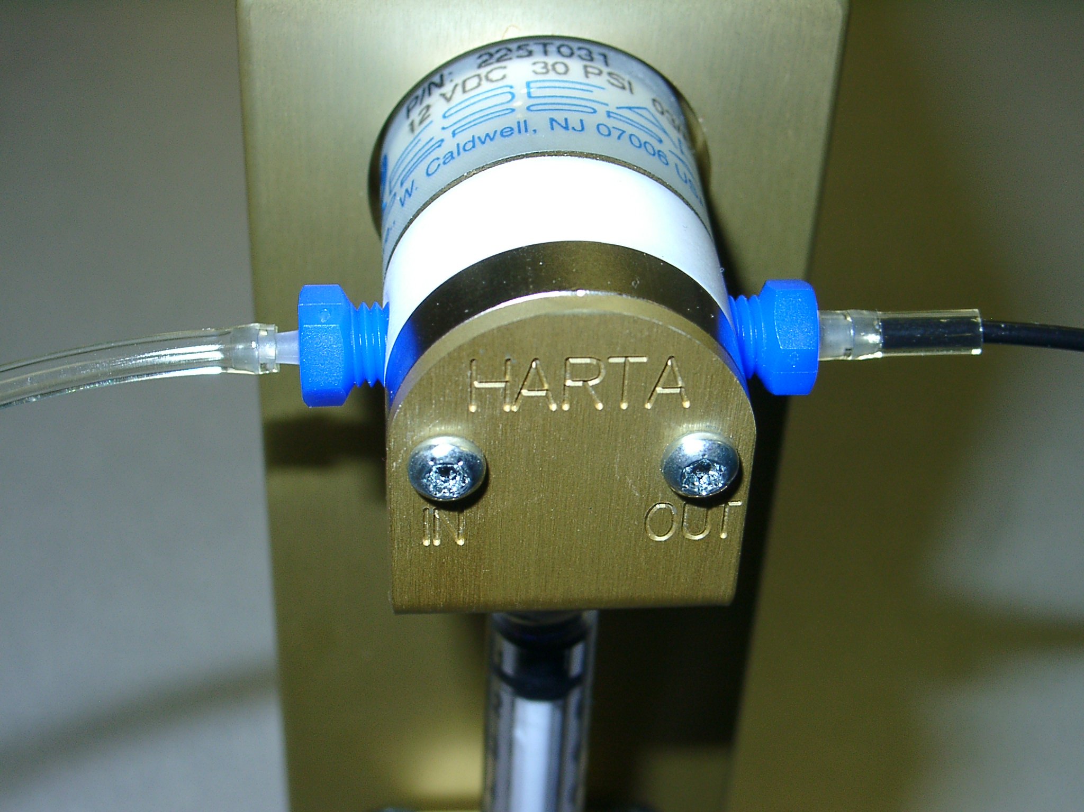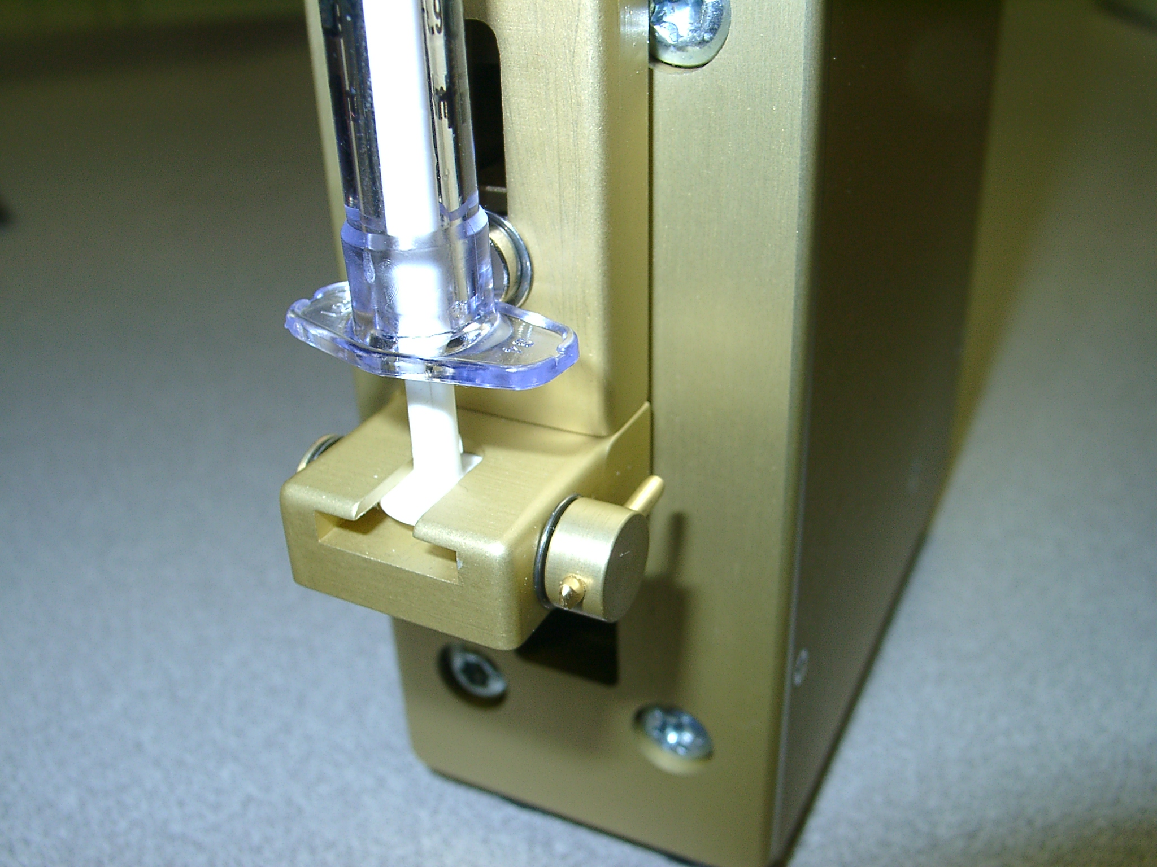
Fig. 1 Fig. 2
A
B
A
B

HARTA INSTRUMENTS, INC.
8 RUSSELL AVE, UNIT 106, GAITHERSBURG, MD 20878
PHONE:301-948-8868. EMAIL: HARTA@EROLS.COM
WWW.HARTACORPORATION.COM

